Name: KEY | Date:

Indigenous Environmental Data Science

Module 1: Mercury Levels in Fish

Task | Check when complete
Lesson 1: Getting Started in R

Goals:
- Download and install R and R studio
- Identify and label the 4 main windows of the R interface
- Create a project connected to a Github repository
- Identify:
  - Code chunk
  - Symbols for beginning and ending a code chunk
  - Comments
- Clear the environment
- Run a chunk of code
- Install and load packages
Download R
Download R studio
Identify and label the 4 main windows in R.
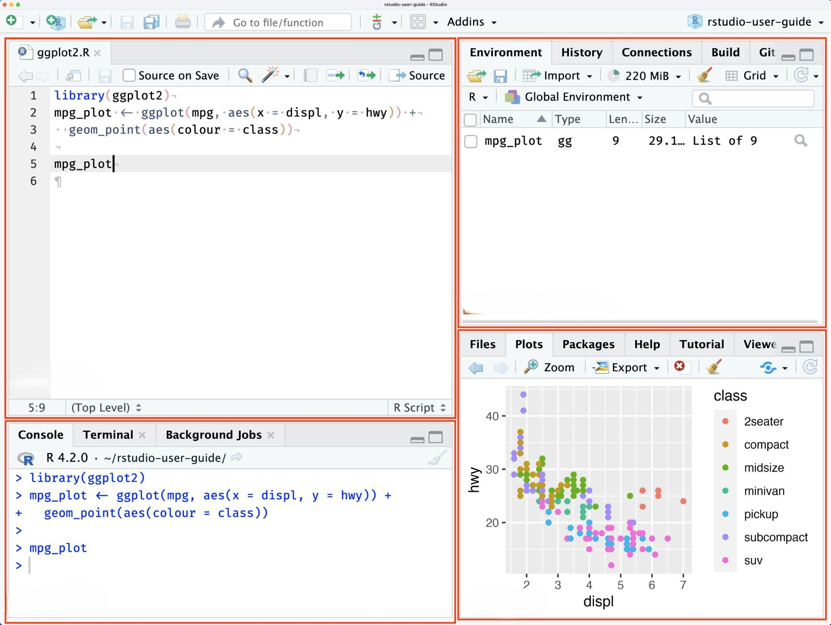
Open a New Project and connect to the data from Github
Differentiate between code and noncode chunks in the Source Editor
Clear the environment
Run a chunk of code
Install the tidyverse package
Load the tidyverse package
Lesson 1: Calculating Screening Values for Mercury in Fish
Goals:
- Calculate the screening value for mercury of fish
- Create a dataframe (table) that contains:
  - Weight of person
  - Number of times consuming fish per week
  - Calculated screening value
- Create a graph of the dataframe using ggplot2
- Describe the relationships between weight, consumption, and screening values (safe limits)
Calculate the safe limit of consumption of fish per week for someone that is 160 lbs:
$$Safe limit = reference dose * weight *0.45/consumption rate$$
- 160 lbs = ______0.46____
Change the value for weight or days per week, and record the changes to the safe limit.
Weight (lbs) | Number of days per week | Safe Limit
160 | 1 | 0.46
160 | 2 | 0.23
120 | 1 | 0.34
120 | 2 | 0.18

Question: What is the relationship between screening value (safe limit) and the number of servings?
Answer: screening value decreases as number of servings per week increase

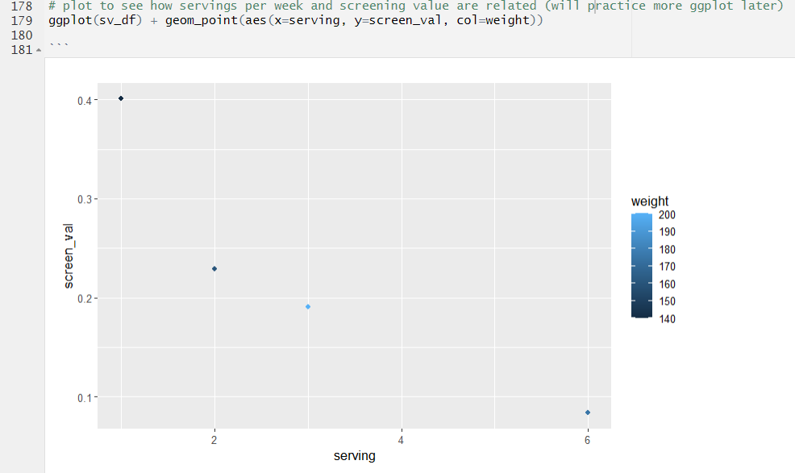
Question: How would you describe this graph and the relationship between screening value, consumption rate, and weight? What happens to the distribution in screening values as the servings per week increase?
Answer:
Screening values decrease with higher servings per week and with less body weight. The distribution of screening values gets smaller as servings per week increase, meaning if you frequently eat fish then weight isn’t as big of a factor.

Question: With this information in mind, consider how to make decisions with the data on mercury content in fish -- how should we consider the screening value for different ages? For example, what screening value would be safer for children, who weigh less than the average adult?
Answer:
Children and people who weigh less should use a smaller screening value, below 0.4.

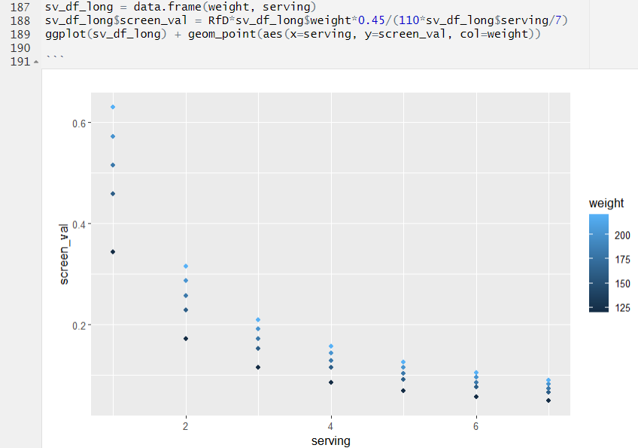
Lesson 2: Load and Explore 1998 Fish Data

Goals:
- Load in the 1998 fish data set
- View the entire data set in spreadsheet form
- View a truncated version of the data set
- Identify the number of rows and columns in the 1998 fish data set
Run code to load 1998 fish data
Run code to view the 1998 fish data in spreadsheet form
Run code to view the first 6 rows of the 1998 fish data
Question: What are the columns in the R dataframe called fish_1998?

Answer:

X, length, mercury

Question: What sorts of questions could the tribal fishery managers answer with this data?

Answer: What is the distribution of mercury levels in fish? What is the average mercury level? What is the distribution of fish length? What is the largest fish length? This question is open ended and really any answer in the format of a question that makes sense could be accepted

Question: How many fish did the managers measure mercury on in 1998?

Answer: ___300____________
Lesson 3: Calculate the Descriptive Statistics of the 1998 Levels of Mercury

Goals:
- Identify the descriptive statistics associated with the 1998 fish data set
- Analyze data points from the 1998 fish data set to answer the following questions for tribal fishery managers:
  - Do the mercury levels in local fish belly fat exceed the maximum safe limit of mercury to be consumed?
  - Is there a relationship between the amount of mercury in fish and fish size?
Run code to determine the mean.
Question: What is the mean level of mercury in the data?

Answer: _____0.45________
Question: Why would knowing the mean (average) amount of mercury in fish be useful for fishery managers and the community?

Answer:
This would be useful because the average represents what might typically be found (this answer could be open ended)

Run code to determine the median.
Question: What is the median level of mercury in the data?

Answer: ________0.41_____
Question: How would we interpret these median and mean values? Should the K'avi community be concerned?

Answer: the mean being greater than median suggests the mercury values skew right, and there are some values beyond the safe screening level, which could cause concern

Run code to determine the minimum and maximum values.
Question: What is the minimum level of mercury in the data?

Answer: _______0.0078______

Question: What is the maximum level of mercury in the data?

Answer: ___1.89__________

Question: How would we interpret these maximum and minimum values? Are they as important as the mean (average)?

Answer:
Could respond with something like: min and max tell us the range of values, and the max is useful in this case because it tells us there are values beyond the screening levels. It’s useful to use both the mean and the range to learn about a data set

Run code to determine the descriptive statistics, which includes the minimum, maximum, mean, and median, as well as the 1st and 3rd quartile.
Question: Write down your descriptive statistics results below.

Answer:

Min | 1st Qu. | Median | Mean | 3rd Qu. | Max
0.0078 | 0.28 | 0.41 | 0.44 | 0.56 | 1.89

Question: Looking at all of these values, are there unsafe levels of mercury in local fish? Are there dangerous levels of mercury in most fish, or only some?

Answer:

Lesson 4: Use ggplot package to Generate a Graph of Mercury Concentrations

Goals:
- Create a graph using the ggplot2 package to visualize mercury concentrations
- Analyze the distribution of mercury in fish to determine how often fish have mercury levels above the EPA recommended safe level in 1998
Question: What does this distribution tell us about the mercury levels in the fish?
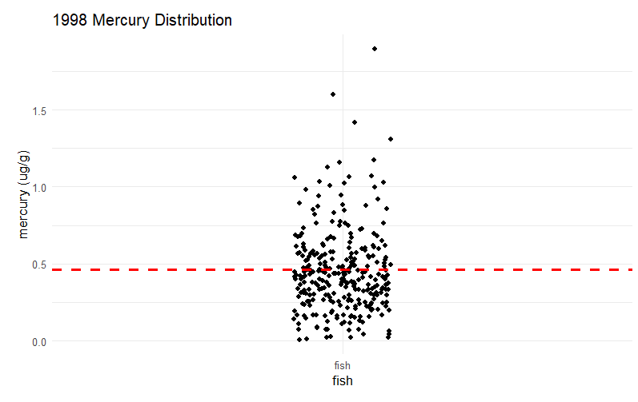
Answer: This answer could include a variety of different things. For example: the values of mercury levels in fish range from close to zero to as high as over 1.5. There are a few outliers, but most of the values fall between 0.25 and 0.75. There are several points above the screening value of 0.46

Question: Look back at the min, max, median, and mean values that were calculated above. Where would these values fall on this graph? Are the mean and median values above or below the level suggested by the EPA?
Answer:
Mean and median are below the screening value of mercury. We can use the boxplot to find where the descriptive statistics fall on this graph.

Question: From looking at this graph, are there unsafe levels of mercury in local fish?
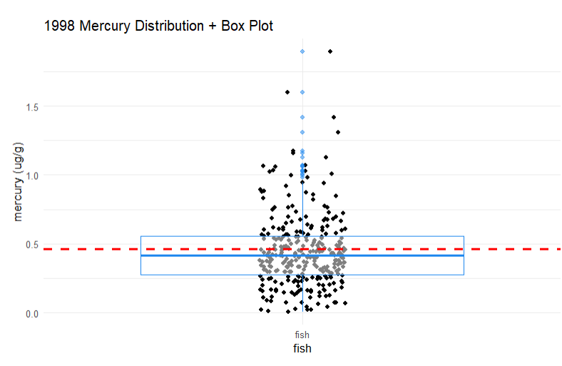
Answer:

Question: If so, is it in most fish, or only some? Did this graph tell you anything different than the summary statistics, or did it just tell you the same information in a different way?
Answer:

Question: In 1998, was it safe for members of the K'avi community to eat fish from these waters?
Answer: it depends how often they were eating fish. If they ate every day, then it was probably not safe. If it was once a week then it was safer.

Question: How comfortable would you have been in 1998 about eating a fish that you caught?

Answer:
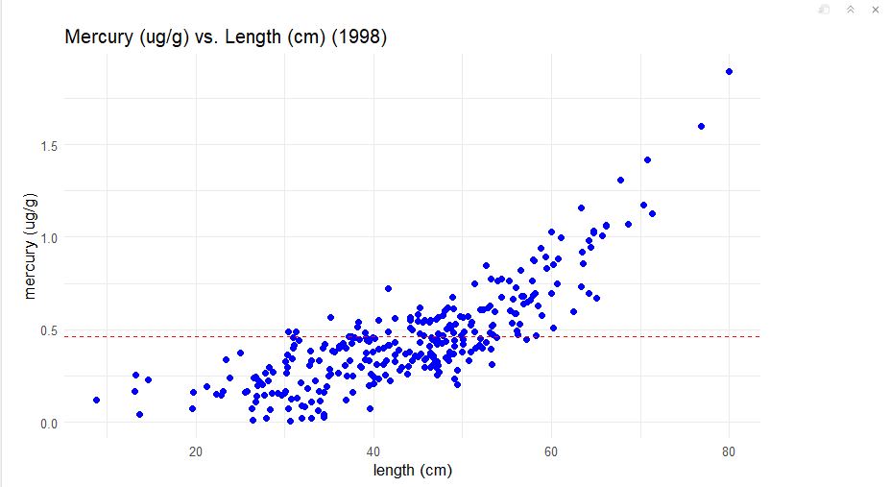
Question: What does this tell us about the relationship between fish length and mercury levels?
Answer: as fish length increases, mercury content increases. There is a positive relationship.

Question: Are there certain lengths of fish that exceed the FDA screening value?
Answer: starting around 30cm, fish could contain mercury above the screening value

Question:If you caught a fish in 1998, would this graph help you decide whether the fish was safe?

Answer: measuring the length of the fish would give an idea of the potential amount of mercury it contains

Lesson 5: Load in and Explore 2023 Data
Goals:
- Load in the 2023 fish data set
- View the entire 2023 fish data set in spreadsheet form
- View a truncated version of the 2023 fish data set
- Identify the number of rows and columns in the 2023 fish data set
Load “tidyverse” package
Install and load “patchwork” package
Run code to load 2023 fish data
Write code for head() prompt to see the first six rows of data
Question: What are the variables in the 2023 fish data set?
Answer: X, length, mercury

Write code for dim() to identify the number of rows and columns.

Question: How many rows and columns are in the data set?
Answer: 300 rows x 3 columns

Lesson 7: Calculate the Descriptive Statistics of the 2023 Levels of Mercury

- Identify the descriptive statistics associated with the 2023 fish data set
- Analyze data points from the 2023 fish data set to answer the following questions for tribal fishery managers:
  - Do the mercury levels in local fish belly fat exceed the maximum safe level of mercury to be consumed?
Question: Write down your descriptive statistics results for 2023 below.

Answer:

Year | Min | 1st Qu. | Median | Mean | 3rd Qu. | Max
1998 | 0.007764 | 0.278103 | 0.413540 | 0.448118 | 0.557474 | 1.894938
2023 | 0.0029 | 0.18 | 0.28 | 0.34 | 0.42 | 1.62

Question: How do the mean and median values of mercury in 2023 compare to the EPA's standard?

Answer: the mean and median in 2023 are lower than the max screening value of 0.46

Question: Do the descriptive statistics suggest that the mercury levels in fish have improved since 1998?

Answer: yes, mercury levels decreased for all descriptive statistics compared to 1998

Lesson 8: Making Graphs to Learn if the Size of Safe Fish Has Changed

- Create a plot of the relationship between mercury and fish length in 1998
- Create a plot of the relationship between mercury and fish length in 2023
- Plot and analyze the 1998 and 2023 fish data side-by-side
  - Is there a relationship between the amount of mercury in fish and fish length?
- Interpret the results to describe the efficacy of removing contaminated sediment
Run code to plot 1998 fish data.
Run code to plot 2023 fish data.
Run code to plot 1998 and 2023 side-by-side. This is why we needed the “patchwork” package.
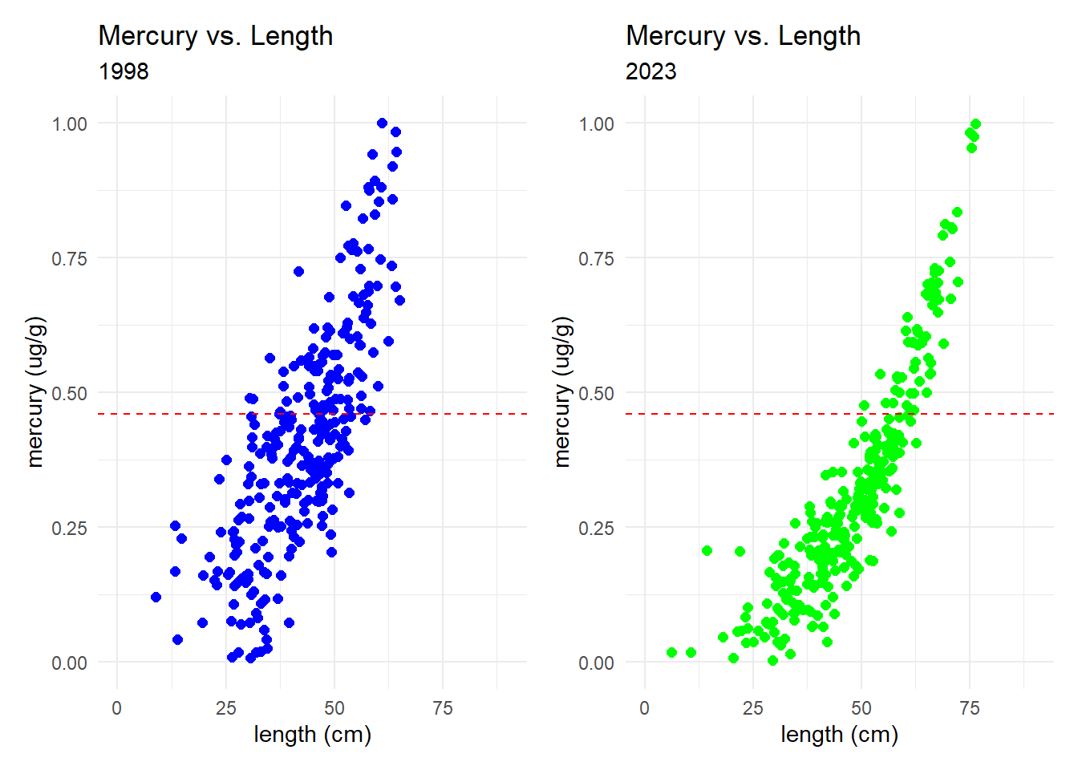
Question: What is the safest large size fish to eat based on the 2023 dataset? How does this compare to the safest largest size fish that could be eaten based on the 1998 dataset?
Answer: this answer is based on visually inspecting graph, so there could be a range of answers. For 2023, around 50cm is safe to eat. For 1998 it could be from 27-30cm. Looking for largest value where the points fall below the red dashed line.

Based on these plots, do you think the efforts since 1998 to clean mercury from the sediments were successful?
Answer: it seems like the efforts were working because mercury values have decreased

Work with a group to describe the evidence from these graphs for the success of the clean-up effort in a way that would be useful for the K'avi community.
Answer: this is open ended, but the answer could include the description of the graph and maybe some discussion about how best to communicate these findings

